- Lists, Links and Images
a. Write a HTML program, to explain the working of lists.
Note: It should have an ordered list, unordered list, nested lists and ordered list in an unordered list and definition lists.
Solution:
<!DOCTYPE html>
<html>
<head>
<title>HTML Nested Unordered List</title>
</head>
<body>
<h3>Ordered List</h3>
<ol>
<li>Apple</li>
<li>Banana</li>
<li>Mango</li>
<li>Orange</li>
</ol>

<h3>Un-Ordered List</h3>
<ul>
<li>Apple</li>
<li>Banana</li>
<li>Mango</li>
<li>Orange</li>
</ul>

<h3>Nested List</h3>
<ul>
<li>Fruits</li>
<ul>
<li>Apple</li>
<li>Banana</li>
<li>Mango</li>
<li>Orange</li>
</ul>
<li>Vegetables</li>
<ul>
<li>Spinach</li>
<li>Cauliflower</li>
<li>Beetroot</li>
</ul>
<li>Cereals</li>
<li>Nuts</li>
</ul>

<j3>Ordered List in an Unordered list</h3>
<ul>
<li>Fruits</li>
<ol>
<li>Apple</li>
<li>Banana</li>
<li>Mango</li>
<li>Orange</li>
</ol>
<li>Vegetables</li>
<ol>
<li>Spinach</li>
<li>Cauliflower</li>
<li>Beetroot</li>
</ol>
<h3>The dl, dd, and dt elements</h3>
<p>These three elements are used to create a description list:</p>
<dl>
<dt>Coffee</dt>
<dd>Black hot drink</dd>
<dt>Milk</dt>
<dd>White cold drink</dd>
</dl>
</body>
</html>

Output:
Ordered List
- Apple
- Banana
- Mango
- Orange
UnOrdered List
- Apple
- Banana
- Mango
- Orange
Nested List
- Fruits
  - Apple
  - Banana
  - Mango
  - Orange
- Vegetables
  - Spinach
  - Cauliflower
  - Beetroot
- Cereals
- Nuts
Ordered List in an Unordered list
- Fruits
  - Apple
  - Banana
  - Mango
  - Orange
- Vegetables
  - Spinach
  - Cauliflower
  - Beetroot

The dl, dd, and dt elements
These three elements are used to create a description list:
Coffee
Black hot drink
Milk
White cold drink

b. Write a HTML program, to explain the working of hyperlinks using <a> tag and href, target Attributes.

<!DOCTYPE html>
<html>
<body>

<h1>HTML Links</h1>

<p><a href="link your first program file here">Click Here!</a></p>

</body>
</html>

Output:
Note: Your first program output is to be displayed here

c. Create a HTML document that has your image and your friend’s image with a specific height and width. Also when clicked on the images it should navigate to their respective profiles.

<!DOCTYPE html>
<html>
<head>
<title>Our Images</title>
</head>
<body>
<h1>Our Images</h1>
<a href="your_profile_url.html">
<img src="your_image_path.jpg" alt="Your Name" width="200" height="200">
</a></br>

<a href="friend_profile_url.html">
<img src="friend_image_path.jpg" alt="Friend's Name" width="200" height="200">
</a>
</body>
</html>
Output:
Note: first you need to create yours and your friends profile html pages and the same to be linked with the images.

d. Write a HTML program, in such a way that, rather than placing large images on a page, the preferred technique is to use thumbnails by setting the height and width parameters to something like to 100*100 pixels. Each thumbnail image is also a link to a full sized version of the image. Create an image gallery using this technique.

<!DOCTYPE html>
<html>
<head>
<title>Image Gallery</title>
<style>
.thumbnail {
width: 100px;
height: 100px;
border: 1px solid #ccc;
margin: 5px;
}
</style>
</head>
<body>

<h1>Image Gallery</h1>

<a href="images/image1_full.jpg">
<img src="images/image1_thumb.jpg" alt="Image 1" class="thumbnail">
</a>

<a href="images/image2_full.jpg">
<img src="images/image2_thumb.jpg" alt="Image 2" class="thumbnail">
</a>

<a href="images/image3_full.jpg">
<img src="images/image3_thumb.jpg" alt="Image 3" class="thumbnail">
</a>

</body>
</html>

Output:
Note: Update your output here

2. HTML Tables, Forms and Frames
a) Write a HTML program, to explain the working of tables. (use tags: <table>, <tr>, <th>, <td> and attributes: border, rowspan, colspan)

<html>
<head><title>Table</title></head>
<body>
<caption align="center">Student Details</caption>
<table border="1">
<tr> Student Details
S No | Name | Sem
1 | Ramalingam | IIIyr IInd Sem
2 | Siva | IIIyr IInd Sem
3 | Arun Kumar | IIyr IInd Sem
4 | Varun Tilak | IIyr IInd Sem
Total |  | 4
<th align="center">S No</th>
<th align="center">Name</th>
<th align="center">Sem</th> </tr>
<tr>
<td>1</td>
<td>Ram</td>
<td rowspan="2">IIIyr IInd Sem</td>
</tr>
<tr>
<td>2</td>
<td>Siva</td>
</tr>
<tr>
<td>3</td>
<td>Kumar</td>
<td rowspan="2">IIyr IInd Sem</td>
</tr>
<tr>
<td>4</td>
<td>Varun</td>
</tr>
<tr>
<td colspan="2" align="center">Total</td>
<td align="center">4</td>
</tr>
</table>
</body>
</html>

b) Write a HTML program, to explain the working of tables by preparing a timetable. (Note: Use <caption> tag to set the caption to the table & also use cell spacing, cell padding, border, rowspan, colspan etc.).

<!DOCTYPE html>
<html>
<head>
<title>Time Table</title>
<style>
body {
font-family: Arial, sans-serif;
background-color: #f8f9fa;
margin: 0;
padding: 0;
}
h1 {
text-align: center;
color: #343a40;
}

table {
border-collapse: collapse;
margin: 20px auto;
background-color: #fff;
border: 2px solid #dee2e6;
box-shadow: 0 2px 4px rgba(0, 0, 0, 0.1);
}
th,
td {
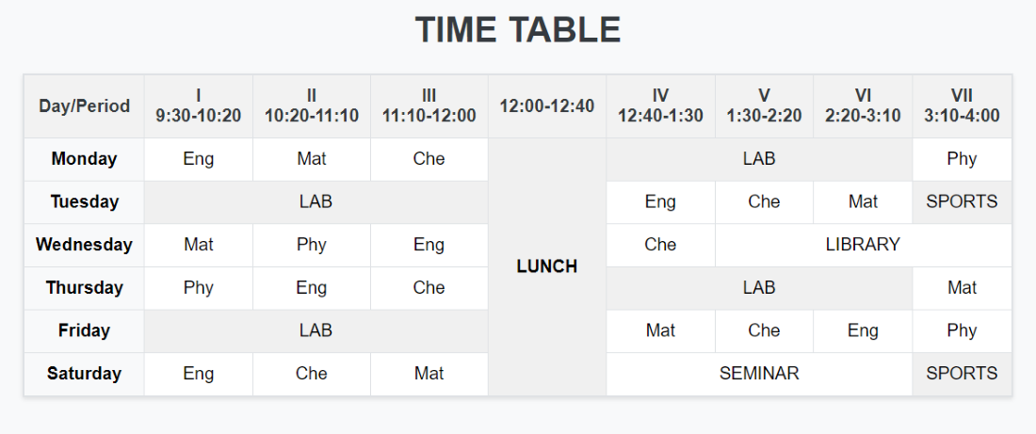
border: 1px solid #dee2e6;
padding: 10px;
text-align: center;
}
th {
background-color: #f2f2f2;
color: #343a40;
}
.highlight {
background-color: #f8f9fa;
}
.special {
background-color: #f0f0f0;
}
</style>
</head>
<body>
<h1>TIME TABLE</h1>
<table>
<tr>
<th>Day/Period</th>
<th>I<br>9:30-10:20</th>
<th>II<br>10:20-11:10</th>
<th>III<br>11:10-12:00</th>
<th>12:00-12:40</th>
<th>IV<br>12:40-1:30</th>
<th>V<br>1:30-2:20</th>
<th>VI<br>2:20-3:10</th>
</tr>
<tr>
<td class="highlight"><b>Monday</b></td>
<td>Eng</td>
<td>Mat</td>
<td>Che</td>
<td rowspan="6" class="special"><b>LUNCH</b></td>
<td colspan="3" class="special">LAB</td>
</tr>
<tr>
<td class="highlight"><b>Tuesday</b></td>
<td colspan="3" class="special">LAB</td>
<td>Eng</td>
<td>Che</td>
<td>Mat</td>
</tr>
<tr>
<td class="highlight"><b>Wednesday</b></td>
<td>Mat</td>
<td>Phy</td>
<td>Eng</td>
<td>Che</td>
<td colspan="2">LIBRARY</td>
</tr>
<tr>
<td class="highlight"><b>Thursday</b></td>
<td>Phy</td>
<td>Eng</td>
<td>Che</td>
<td colspan="3" class="special">LAB</td>
</tr>
<tr>
<td class="highlight"><b>Friday</b></td>
<td colspan="3" class="special">LAB</td>
<td>Mat</td>
<td>Che</td>
<td>Eng</td>
</tr>
<tr>
<td class="highlight"><b>Saturday</b></td>
<td>Eng</td>
<td>Che</td>
<td>Mat</td>
<td colspan="3">SEMINAR</td>
</tr>
</table>
</body>
</html>

c). Write a HTML program, to explain the working of forms by designing Registration form. (Note: Include text field, password field, number field, date of birth field, checkboxes, radio buttons, list boxes using <select>&<option> tags, <text area> and two buttons ie: submit and reset. Use tables to provide a better view).

<!DOCTYPE html>
<html lang="en">

<head>
<meta charset="UTF-8">
<meta name="viewport" content="width=device-width, initial-scale=1.0">
<title>HTML Form</title>
<style>
body {
display: flex;
justify-content: center;
align-items: center;
height: 100vh;
margin: 0;
background-color: #f0f0f0;
}

form {
width: 400px;
background-color: #fff;
padding: 20px;
border-radius: 8px;
box-shadow: 0 0 10px rgba(0, 0, 0, 0.1);
}

fieldset {
border: 1px solid black;
padding: 10px;
margin: 0;
}

legend {
font-weight: bold;
margin-bottom: 10px;
}

label {
display: block;
margin-bottom: 5px;
}

input[type="text"],
input[type="email"],
input[type="password"],
textarea,
input[type="date"] {
width: calc(100% - 20px);
padding: 8px;
margin-bottom: 10px;
box-sizing: border-box;
border: 1px solid #ccc;
border-radius: 4px;
}

.gender-group {
margin-bottom: 10px;
}

.gender-group label {
display: inline-block;
margin-left: 10px;
}

input[type="radio"] {
margin-left: 10px;
vertical-align: middle;
}

input[type="submit"] {
padding: 10px 20px;
border-radius: 5px;
cursor: pointer;
}
input[type="reset"] {
padding: 10px 20px;
border-radius: 5px;
cursor: pointer;
}
</style>
</head>

<body>
<form>
<fieldset>
<legend>User Personal Information</legend>
<label for="name">Enter your full name:</label>
<input type="text" id="name" name="name" required />
<label for="email">Enter your email:</label>
<input type="email" id="email" name="email" required />
<label for="password">Enter your password:</label>
<input type="password" id="password" name="pass" required />
<label for="confirmPassword">Confirm your password:</label>
<input type="password" id="confirmPassword" name="confirmPass" required />
<label>Enter your gender:</label>
<div class="gender-group">
<input type="radio" name="gender" value="male" id="male" required />
<label for="male">Male</label>
<input type="radio" name="gender" value="female" id="female" />
<label for="female">Female</label>
<input type="radio" name="gender" value="others" id="others" />
<label for="others">Others</label>
</div>
<label for="dob">Enter your Date of Birth:</label>
<input type="date" id="dob" name="dob" required />
<label for="address">Enter your Address:</label>
<textarea id="address" name="address" required></textarea>
Languages Known:<br>
<li><input type="checkbox" name="Language" value="English" />English</li>
<li><input type="checkbox" name="Language" value="Hindi" />Hindi</li>
<li><input type="checkbox" name="Language" value="Telugu" />Telugu</li>
<li><input type="checkbox" name="Language" value="Tamil" />Tamil</li>
<li><input type="checkbox" name="Language" value="Malayalam" />Malayalam</li><br>
<label for="B.Tech Degree">Choose your Degree:</label>
<select name="B.Tech" id="B.Tech">
<option value="CSE">CSE</option>
<option value="CS">CYBER SECURITY</option>
<option value="AI&ML">AI&ML</option>
<option value="IOT">IOT</option>
</select><br><br>
<label for="Experience">No. of Years Experience (between 0 and 15):</label>
<input type="number" id="quantity" name="quantity" min="0" max="15">
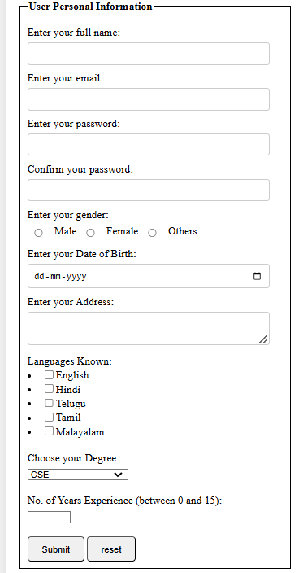
<br><br>
<input type="submit" value="Submit" />
<input type="reset" value="reset">

</fieldset>
</form>
</body>

</html>

d) Write a HTML program, to explain the working of frames, such that page is to be divided into 3 parts on either direction. (Note: first frame image, second frame paragraph, third frame ◻ hyperlink. And also make sure of using “no frame” attribute such that frames to be fixed).

<!DOCTYPE html>
<html>
<head>
<title>HTML Frames</title>
</head>
<frameset cols="25%,50%,25%">
<frame name="left" src="D:\ml\img.html" />
<frame name="center" src="D:\ml\p.html" />
<frame name="right" src="D:\ml\hyperlink.html" />
<noframes>
<body>
Your browser does not support frames.
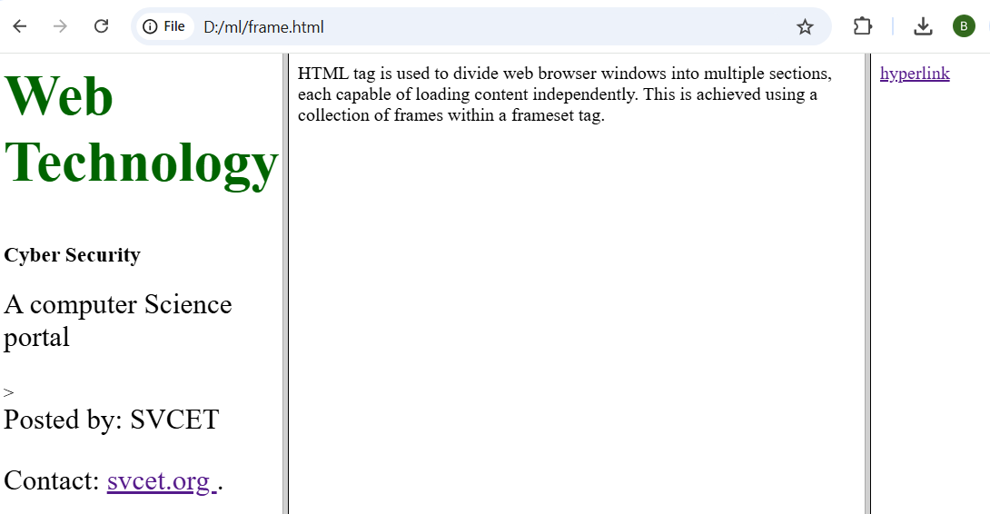
</body>
</noframes>
</frameset>
</html>

Week 3 HTML 5 and Cascading Style Sheets, Types of CSS
  - Write a HTML program, that makes use of <article>, <aside>, <figure>, <figcaption>,
<footer>, <header>, <main>, <nav>, <section>, <div>, <span> tags.

<html>
<title>Article Tag</title>
<head>
<style>
h1 {
color: #006400;
font-size: 50px;
text-align: left; }
p {
font-size: 25px;
text-align: left;
margin-top: 0; }
.myDiv {
border: 5px outset red;
background-color: lightblue;
text-align: center; }
</style>
</head>
<body>
<header>
<h1>Web Technology</h1>
<h3>Cyber Security</h3>
<p>A computer Science portal</p>
</header>
<main>
<h1>Important Residences</h1>
<p> A few of them are
Rashtrapati Bhavan,
White House etc
</p>
<article>
<h1>Rashtrapati Bhavan</h1>
<p> It is the home of the President of India. </p>
</article>
<article>
<h1>The White House</h1>
<p> It is the home of the
President of United
States of America.
</p>
</article>
</main>
<section>
<h1>Data Structure</h1>
<p>
Data Structure is a data
organization and storage
format that enables efficient
access and modification.
</p>
</section>

<aside>
<h4>SVCET</h4>
<p>Cyber Security is a computer Science platform
where you can learn good programming.
</p>
</aside>
<figure>
<img src=“D:\svcet.jpg"
alt=“SVCET"
style="width:20%">
<figcaption>
SVCET Logo
</figcaption>
</figure>
<div class="myDiv">
<h2>This is a heading in a div element</h2>
<p>This is some text in a div element.</p>
</div>
<p>The dog has <span style="color:blue">blue</span> eyes.</p>
<nav>
<a href="/home/">
Home
</a> |
<a href="/about-us/">
About Us
</a> |
<a href="/data-structure/">
Data Structure
</a> |
<a href="/operating-system/">
Operating System
</a>
</nav>

<footer>
<p> Posted by: SVCET </p>
<p>
Contact:
<a href=" https://svcetedu.org/ ">svcet.org
</a>.
</p>
</footer>
</body>
</html>
b. Write a HTML program, to embed audio and video into HTML web page.
Solution:

<!DOCTYPE html>
<html>
<head>
<title>Page contain audio and video</title>
</head>
<body>
<h2>Click play button to play audio</h2>
<audio src="d:\ml\oxp.wav" controls></audio><br><br>

<h2>Click play button to play video</h2>
<video src="d:\ml\NN Video.mp4" controls></video>
</body>
</html>

Output

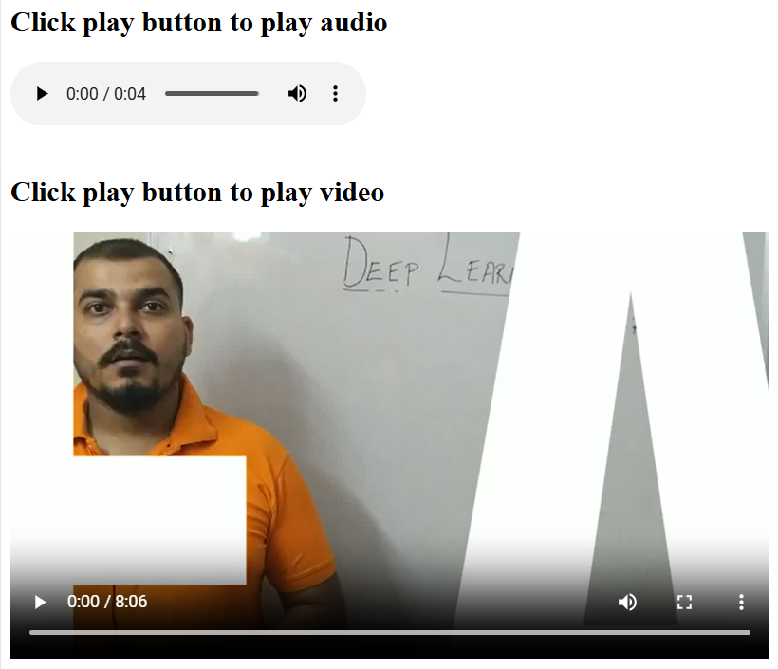

    - Write a program to apply different types (or levels of styles or style specification formats) - inline, internal, external styles to HTML elements. (identify selector, property and value).
Solution:
<!DOCTYPE html>
<html>
<head>
<link rel="stylesheet" href="d:\ml\style.css">
<!... Defining Internal style>
<style>
.SVCET {
text-align: center;
font-size: 25px;
}
.CSE {
color: #009900;
font-size: 50px;
font-weight: bold;
}
.CS {
color:blue;
font-style: bold;
font-size: 20px;
}
</style>
</head>
<body>

<!... Defining and applying the Inline style>

<h1 style="color:#009900;
font-size:50px;
font-style:italic;
text-align:center;">
Inline CSS is designed only for an individual HTML tag
</h1>
<h1>The above Inline style won't be applied for this h1 (heading) tag</h1>

<!... applying Internal style>

<div class="SVCET">
<div class="CSE">Internal CSS</div>

<div class="CS">
It defines a new style for the HTML tags
</div>
</div>
<p class="SVCET">Internal style will apply for this paragraph tag because it can be used multiple times anywhere in this program once the internal style is defined.</p>

<p class="CS">Internal style will apply for this paragraph tag because it can be used multiple times anywhere in this program once the internal style is defined.</p>

<!... applying External style>

<p class="second"> External CSS</p>
<p class="year">External style is defined in a separate file with the name of "file.css" and the same file is linked in this program inside the head tag with the help of link tag.</p>
<p class="Isem">In this program we learned INLINE, INTERNAL, and EXTERNAL CSS</p>
</body>
</html>

Note: Type the following code in a separate file, save it as filename.css, and link the same file name in the above code in the head section.

<!... defining External style>
body {
background-color: powderblue;
}
.second {
color: dark blue;
text-align: center;
font-size: 50px;
}
.year {
color: #009900;
font-size: 30px;
font-style: italic;
}
.Isem {
text-decoration: underline;
font-size: 20px;
}

Output:
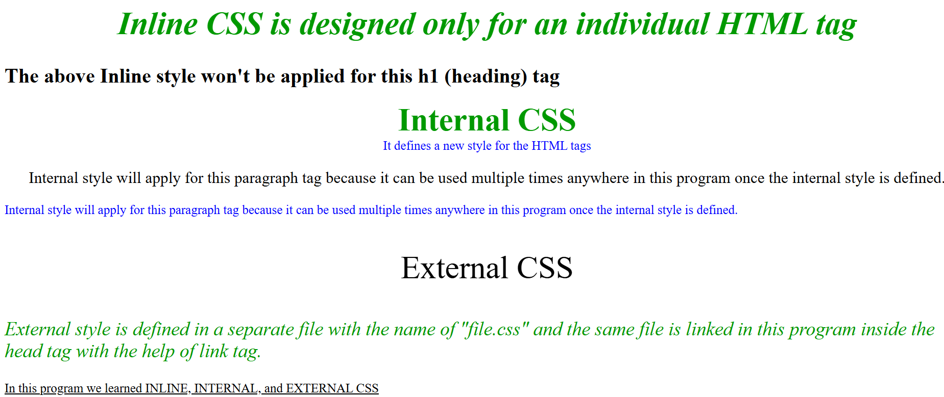

Selector forms
      - Write a program to apply different types of selector forms
        - Simple selector (element, id, class, group, universal)

Soln:

<!DOCTYPE html>
<html>
<head>
<title>CSS Selectors Example</title>
<style>
/* Element Selector */
p {
color: blue;
font-size: 16px;
}

/* ID Selector */
#unique-paragraph {
background-color: lightyellow;
padding: 10px;
}

/* Class Selector */
.highlighted {
font-weight: bold;
color: red;
}

/* Grouping Selector */
h1, h2, h3 {
text-align: center;
font-family: sans-serif;
}

/* Universal Selector (resetting margins and padding - be cautious using this!) */
/* * {
border: 2px solid green;
background-color: beige;
} */

</style>
</head>
<body>

<h1>Heading 1</h1>
<h2>Heading 2</h2>
<h3>Heading 3</h3>

<p>This is a paragraph.</p>
<p class="highlighted">This paragraph is highlighted.</p>
<p>Another paragraph.</p>

<p id="unique-paragraph">This paragraph has a unique ID.</p>

<p class="highlighted">Another highlighted paragraph.</p>
</body>
</html>

        - Combinator selector (descendant, child, adjacent sibling, general sibling)

Soln:

<!DOCTYPE html>
<html>
<head>
<title>CSS Combinator Selectors</title>
<style>
/* Descendant Combinator (space) */
div p {
color: blue;
}

/* Child Combinator (>) */
div > span {
font-weight: bold;
}

/* Adjacent Sibling Combinator (+) */
h2 + p {
background-color: lightgray;
}

/* General Sibling Combinator (~) */
h2 ~ ul {
border: 1px solid red;
}

/* adding some basic styling for better readability */
div, section, article {
border: 1px solid #ccc;
padding: 10px;
margin: 10px;
}
</style>
</head>
<body>

<div>
<p>This paragraph is inside a div (descendant).</p>
<span>This span is a direct child of the div (child).</span>
<section>
<p>This paragraph is inside a section, inside a div (descendant).</p>
</section>
</div>

<h2>Adjacent Sibling Example</h2>
<p>This paragraph is an adjacent sibling of the h2.</p>
<p>This paragraph is also inside the same div but it is not adjacent to h2.</p>

<h2>General Sibling Example</h2>
<ul>
<li>Item 1</li>
<li>Item 2</li>
</ul>
<p>This paragraph is a sibling, but not selected.</p>
<ul>
<li>Item 3</li>
<li>Item 4</li>
</ul>

</body>
</html>

iii) Pseudo-class selector

Soln:

<!DOCTYPE html>
<html>
<head>
<title>Pseudo-class Selector Example</title>
<style>
/* Example 1: :hover */
.my-button {
background-color: lightblue;
padding: 10px 20px;
border: none;
cursor: pointer;
}

.my-button:hover {
background-color: darkblue;
color: white;
}

/* Example 2: :nth-child */
ul li:nth-child(odd) {
background-color: #f2f2f2;
}

/* Example 3: :focus */

input[type="text"] {
padding: 5px;
border: 1px solid #ccc;
}

input[type="text"]:focus {
border: 2px solid blue;
outline: none; /* Removes default browser outline */
}

/* Example 4: :active */

.my-button-active {
background-color: lightgreen;
padding: 10px 20px;
border: none;
cursor: pointer;
}

.my-button-active:active {
background-color: darkgreen;
color: white;
}

/* Example 5: :first-child and :last-child */
.my-list li:first-child{
color: red;
}
.my-list li:last-child{
font-weight: bold;
}

</style>
</head>
<body>

<h2>:hover Example</h2>
<button class="my-button">Hover Me</button>

<h2>:nth-child Example</h2>
<ul>
<li>Item 1</li>
<li>Item 2</li>
<li>Item 3</li>
<li>Item 4</li>
<li>Item 5</li>
</ul>

<h2>:focus Example</h2>
<input type="text" placeholder="Enter text">

<h2>:active Example</h2>

<button class="my-button-active">Click and Hold</button>

<h2>:first-child and :last-child Example</h2>
<ul class="my-list">
<li>First Item</li>
<li>Second Item</li>
<li>Third Item</li>
<li>Last Item</li>
</ul>

</body>
</html>

iv) Pseudo-element selector

Soln:

<!DOCTYPE html>
<html>
<head>
<style>
p::first-line {
color: blue;
font-weight: bold;
}

p::before {
content: "Read this: ";
color: red;
font-weight: bold;
}

p::after {
content: " (The End)";
font-style: italic;
}

.box::before {
content: ""; /* Must have content for pseudo-elements to display */
display: block; /* Allows you to set width and height */
width: 20px;
height: 20px;
background-color: green;
position: absolute;
top: -10px;
left: -10px;
}

.box {
position: relative; /* Needed for absolute positioning of ::before */
width: 200px;
height: 100px;
border: 1px solid black;
padding: 20px;
}

a::after {
content: " (" attr(href) ")"; /*shows the href in parenthesis after the link*/
}

::selection { /* styles the selected text */
background-color: yellow;
color: black;
}

</style>
</head>
<body>

<p>This is a paragraph of text. The first line will be blue and bold. This is a longer line to demonstrate the first-line pseudo-element. This part is not the first line.</p>

<div class="box">
This is a box with a pseudo-element before it.
</div>

<a href="https://www.example.com">Example Link</a>

</body>
</html>

v) Attribute selector

Soln:

<!DOCTYPE html>
<html>
<head>
<title>Attribute Selector Example</title>
<style>
/* Selects all input elements with the type attribute set to "text" */
input[type="text"] {
border: 2px solid blue;
padding: 5px;
margin: 5px;
}

/* Selects all input elements with the type attribute set to "password" */
input[type="password"] {
border: 2px solid red;
padding: 5px;
margin: 5px;
}

/* Selects all anchor (a) elements that have an href attribute */
a[href] {
color: green;
text-decoration: none;
}

/* Selects all anchor elements whose href attribute begins with "https://" */
a[href^="https://"] {
font-weight: bold;
}

/* Selects all input elements that have a "data-custom" attribute */
input[data-custom] {
background-color: lightyellow;
}

/* Selects all input elements whose data-custom attribute ends with "test" */
input[data-custom$="test"]{
font-style: italic;
}

/* Selects all input elements whose data-custom attribute contains "middle"*/
input[data-custom*="middle"]{
border: 3px dotted purple;
}

</style>
</head>
<body>

<form>
<label for="username">Username:</label><br>
<input type="text" id="username" name="username" value="JohnDoe"><br><br>

<label for="password">Password:</label><br>
<input type="password" id="password" name="password" value="secret"><br><br>

<input type="text" data-custom="first-test" value="Custom 1"><br><br>

<input type="text" data-custom="middle-value" value="Custom 2"><br><br>

<input type="text" data-custom="another-test" value="Custom 3"><br><br>

<input type="submit" value="Submit">
</form>

<br>

<a href="https://www.example.com">Example Link (HTTPS)</a><br>
<a href="http://www.anotherexample.com">Another Link (HTTP)</a><br>
<a href="/internal/page">Internal Link</a>

</body>
</html>

5. CSS with Color, Background, Font, Text and CSS Box Model
a. Write a program to demonstrate the various ways you can reference a color in CSS.
Soln:
<!DOCTYPE html>
<html>
<head>
<title>CSS Color References</title>
<style>
/* 1. Named Colors */
.named-color {
background-color: lightblue;
color: darkblue;
padding: 10px;
margin-bottom: 10px;
}

/* 2. Hexadecimal Colors */
.hex-color {
background-color: #ff9900; /* Orange */
color: #333; /* Dark gray */
padding: 10px;
margin-bottom: 10px;
}

/* 3. Short Hexadecimal Colors */
.short-hex-color {
background-color: #f0f; /* Magenta */
color: #fff; /* White */
padding: 10px;
margin-bottom: 10px;
}

/* 4. RGB Colors */
.rgb-color {
background-color: rgb(255, 0, 0); /* Red */
color: rgb(255, 255, 255); /* White */
padding: 10px;
margin-bottom: 10px;
}

/* 5. RGBA Colors (with transparency) */
.rgba-color {
background-color: rgba(0, 128, 0, 0.5); /* Semi-transparent green */
color: white;
padding: 10px;
margin-bottom: 10px;
}

/* 6. HSL Colors */
.hsl-color {
background-color: hsl(240, 100%, 50%); /* Blue */
color: white;
padding: 10px;
margin-bottom: 10px;
}

/* 7. HSLA Colors (with transparency) */
.hsla-color {
background-color: hsla(120, 100%, 50%, 0.7); /* Semi-transparent green */
color: black;
padding: 10px;
margin-bottom: 10px;
}

/* 8. currentColor */
.current-color {
color: purple;
border: 5px solid currentColor;
padding: 10px;
margin-bottom: 10px;
}

/* 9. transparent */
.transparent-color{
background-color: transparent;
border: 2px solid black;
padding: 10px;
margin-bottom:10px;
}

</style>
</head>
<body>

<div class="named-color">Named Color (lightblue, darkblue)</div>
<div class="hex-color">Hexadecimal Color (#ff9900, #333)</div>
<div class="short-hex-color">Short Hexadecimal Color (#f0f, #fff)</div>
<div class="rgb-color">RGB Color (rgb(255, 0, 0))</div>
<div class="rgba-color">RGBA Color (rgba(0, 128, 0, 0.5))</div>
<div class="hsl-color">HSL Color (hsl(240, 100%, 50%))</div>
<div class="hsla-color">HSLA Color (hsla(120, 100%, 50%, 0.7))</div>
<div class="current-color">Current Color (purple border)</div>
<div class="transparent-color">Transparent color (black border)</div>

</body>
</html>

b. Write a CSS rule that places a background image halfway down the page, tilting it horizontally. The image should remain in place when the user scrolls up or down.
Soln:
<!DOCTYPE html>
<!DOCTYPE html>
<html>
<head>
<title>Fixed Background Image</title>
<style>
body {
margin: 0;
padding: 0;
height: 2000px; /* Add some height to demonstrate scrolling */
background-color: #f0f0f0;
}

.fixed-background {
position: fixed;
top: 10%; /* Place the image halfway down the page */
left: 0;
width: 20%;
height: 300px; /* Adjust the height to match your image */
background-image: url("d:/ml/svcet.jpg"); /* Replace with your image URL */
background-size: cover;
background-position: center;
transform: rotate(10deg); /* Tilt the image horizontally */
z-index: -1; /* Place the image behind the content */
}
</style>
</head>
<body>
<div class="fixed-background"></div>
<!-- Your page content here -->
<h1>Scroll down to see the fixed background image in action!</h1>
<h1>The background-attachment Property</h1>
<p>The background-image is fixed. Try to scroll down the page.</p>
<p>The background-image is fixed. Try to scroll down the page.</p>
<p>The background-image is fixed. Try to scroll down the page.</p>
<p>The background-image is fixed. Try to scroll down the page.</p>
<p>The background-image is fixed. Try to scroll down the page.</p>
<p>The background-image is fixed. Try to scroll down the page.</p>
<p>The background-image is fixed. Try to scroll down the page.</p>
<p>The background-image is fixed. Try to scroll down the page.</p>
<p>The background-image is fixed. Try to scroll down the page.</p>
<p>The background-image is fixed. Try to scroll down the page.</p>
<p>The background-image is fixed. Try to scroll down the page.</p>
<p>The background-image is fixed. Try to scroll down the page.</p>
<p>The background-image is fixed. Try to scroll down the page.</p>
<p>The background-image is fixed. Try to scroll down the page.</p>
<p>The background-image is fixed. Try to scroll down the page.</p>
<p>The background-image is fixed. Try to scroll down the page.</p>
<p>The background-image is fixed. Try to scroll down the page.</p>
<p>The background-image is fixed. Try to scroll down the page.</p>
<p>The background-image is fixed. Try to scroll down the page.</p>
<p>The background-image is fixed. Try to scroll down the page.</p>
<p>The background-image is fixed. Try to scroll down the page.</p>
<p>The background-image is fixed. Try to scroll down the page.</p>
<p>The background-image is fixed. Try to scroll down the page.</p>
<p>If you do not see any scrollbars, try to resize the browser window.</p>

<!-- Add more content to demonstrate scrolling -->
</body>
</html>

c. Write a program using the following terms related to CSS font and text:
i. font-size ii. font-weight iii. font-style
iv. text-decoration v. text-transformation vi. text-alignment
Soln:
<!DOCTYPE html>
<html>
<head>
<title>CSS Font and Text Properties</title>
<style>
.font-size {
font-size: 20px; /* Example font size */
}

.font-weight {
font-weight: bold; /* Bold text */
}

.font-style {
font-style: italic; /* Italic text */
}

.text-decoration {
text-decoration: underline; /* Underlined text */
}

.text-transform {
text-transform: uppercase; /* Uppercase text */
}

.text-align {
text-align: center; /* Centered text */
}

.combined{
font-size: 24px;
font-weight: 800;
font-style: italic;
text-decoration: line-through;
text-transform: capitalize;
text-align: right;

}
</style>
</head>
<body>

<p class="font-size">This text has a font size of 20px.</p>
<p class="font-weight">This text is bold.</p>
<p class="font-style">This text is italic.</p>
<p class="text-decoration">This text is underlined.</p>
<p class="text-transform">this text is uppercase.</p>
<p class="text-align">This text is centered.</p>
<p class="combined">combined styles example</p>

</body>
</html>

d: Write a program, to explain the importance of CSS Box model using
i. Content ii. Border iii. Margin iv. padding
Soln:
<!DOCTYPE html>
<html>
<head>
<title>CSS Box Model Example</title>
<style>
.box {
width: 200px; /* Content width */
height: 100px; /* Content height */
background-color: lightblue;
border: 5px solid blue; /* Border */
padding: 20px; /* Padding */
margin: 30px; /* Margin */
}

.explanation {
font-family: sans-serif;
padding: 10px;
}

.content-box{
width: 200px;
height: 100px;
background-color: lightgreen;
border: 2px solid green;
}

.border-box{
width: 200px;
height: 100px;
background-color: lightcoral;
border: 10px solid red;
padding: 10px;
box-sizing: border-box; /*demonstrates the box-sizing property*/
}

</style>
</head>
<body>

<div class="box">
This is a box.
</div>

<div class="explanation">
<p><b>Content:</b> The content is the actual text, images, or other elements within the box. In this example, the content area is 200px wide and 100px high, and it has a light blue background.</p>
<p><b>Border:</b> The border surrounds the content and padding. Here, it's a 5px solid blue border.</p>
<p><b>Padding:</b> Padding is the space between the content and the border. It adds space inside the box. In this example, there's 20px of padding on all sides.</p>
<p><b>Margin:</b> Margin is the space outside the border. It creates space between the box and other elements. Here, there's 30px of margin on all sides.</p>

<p><b>Importance:</b> The box model is crucial for controlling the layout and spacing of elements on a web page. It allows you to precisely define the dimensions and positioning of elements, ensuring a consistent and visually appealing design.</p>

<p><b>Content-box vs. Border-box:</b></p>
<div class="content-box">Content-box</div>
<div class="border-box">Border-box</div>
<p>The first box uses the default content-box model. The second box uses the border-box model. Notice the difference in the final size of the boxes, despite having similar width and height values in the css. The border-box model makes it easier to work with elements that have padding and borders.</p>
</div>

</body>
</html>

Applying JavaScript - internal and external, I/O, Type Conversion
- Write a program to embed internal and external JavaScript in a web page.
Soln:
<!DOCTYPE html>
<html>
<head>
<title>Embedding JavaScript</title>
<script>
// Internal JavaScript (within the <head> tag)
function internalFunction() {
alert("This is from internal JavaScript in the head.");
}
</script>
<script src="external.js"></script>
</head>
<body>

<h1>Embedding JavaScript Examples</h1>

<button onclick="internalFunction()">Click for Internal Head Script</button><br><br>
<button onclick="externalFunction()">Click for External Script</button><br><br>
<button onclick="internalBodyFunction()">Click for Internal Body Script</button>

<p id="demo"></p>

<script>
// Internal JavaScript (within the <body> tag)
function internalBodyFunction() {
document.getElementById("demo").innerHTML = "Internal JavaScript in the body changed this
paragraph!";
}
</script>
</body>
</html>
Note: external.js (create this file in the same directory as your HTML file):
// External JavaScript
function externalFunction() {
alert("This is from external JavaScript.");
}
console.log("External script loaded."); //Example of a console log.

- Write a program to explain the different ways for displaying output.
Soln:
<!DOCTYPE html>
<html>
<head>
<title>JavaScript Output Methods</title>
</head>
<body>

<h1>JavaScript Output Methods</h1>

<p id="demo"></p>

<script>
// 1. innerHTML
document.getElementById("demo").innerHTML = "Hello, innerHTML!";

// 2. document.write() (Generally Avoided)
document.write("This is document.write. Use sparingly!");

// 3. alert()
function showAlert() {
alert("This is an alert box!");
}

// 4. console.log() Note:Open your browser's developer console (usually by pressing F12) to see the console.log(), console.error(), console.warn(), and console.info() messages.
console.log("This is a console log message.");

// 5. console.error(), console.warn(), console.info()
console.error("This is an error message.");
console.warn("This is a warning message.");
console.info("This is an informational message.");

// 6. Using textContent
let paragraph = document.createElement("p");
paragraph.textContent = "This is textContent output.";
document.body.appendChild(paragraph);

// 7. Using appendChild and creating elements.
let newDiv = document.createElement("div");
let newText = document.createTextNode("Appended text node.");
newDiv.appendChild(newText);
document.body.appendChild(newDiv);

</script>
<button onclick="showAlert()">Show Alert</button>
</body>
</html>

- Write a program to explain the different ways for taking input.
Soln:
<!DOCTYPE html>
<html><head><title>JavaScript Input Methods</title></head>
<body>
<h1>JavaScript Input Methods</h1>

<p>Enter your name:</p>
<input type="text" id="nameInput"><br><br>
<button onclick="getInputFromInput()">Get Input (Input Element)</button>

<p id="output"></p>
<script>
// 1. Input Element (Text Input)
function getInputFromInput()
{ let name = document.getElementById("nameInput").value;
document.getElementById("output").innerHTML = "Hello, " + name + "!";
}
// 2. prompt()
function getInputFromPrompt()
{ let age = prompt("Please enter your age:", "25"); // Default value "25"
if (age != null)
document.getElementById("output").innerHTML = "Your age is: " + age;
else
document.getElementById("output").innerHTML = "User cancelled prompt.";
}
// 3. Confirm Box
function getInputFromConfirm()
{ let result = confirm("Do you like Javascript?");
if(result)
document.getElementById("output").innerHTML = "User likes Javascript";
else
document.getElementById("output").innerHTML = "User does not like Javascript";
}
// 4. Using a textarea.
function getInputFromTextarea()
{ let text = document.getElementById("myTextarea").value;
document.getElementById("output").innerHTML = "Textarea content: " + text;
}
</script>
<button onclick="getInputFromPrompt()">Get Input (Prompt)</button><br><br>
<button onclick="getInputFromConfirm()">Get Input (Confirm)</button><br><br>

<p>Enter some text:</p>

<textarea id="myTextarea" rows="4" cols="50"></textarea><br><br>
<button onclick="getInputFromTextarea()">Get Input (Textarea)</button>

</body>
</html>
- Create a webpage which uses prompt dialogue box to ask a voter for his name and age. Display the information in table format along with either the voter can vote or not.
Soln:
<!DOCTYPE html>
<html>
<head>
<title>Voter Information</title>
<style>
table {
border-collapse: collapse;
width: 50%;
margin: 20px auto;
}
th, td {
border: 1px solid #ddd;
padding: 8px;
text-align: left;
}
th {
background-color: #f2f2f2;
}
</style>
</head>
<body>

<script>
let name = prompt("Enter your name:");
let age = prompt("Enter your age:");

if (name && age) { // Check if both name and age are provided
age = parseInt(age); // Convert age to a number

let canVote = age >= 18 ? "Yes" : "No";

document.write("<table>");
document.write("<tr><th>Attribute</th><th>Value</th></tr>");
document.write("<tr><td>Name</td><td>" + name + "</td></tr>");
document.write("<tr><td>Age</td><td>" + age + "</td></tr>");
document.write("<tr><td>Can Vote</td><td>" + canVote + "</td></tr>");
document.write("</table>");
} else {
alert("Name and age are required.");
}
</script>

</body>
</html>

Week 7.
a. Write a program using document object properties and methods.
Soln:
<!DOCTYPE html>
<html>
<head>
<title>Document Object Example</title>
</head>
<body>
<h1>Hello, World!</h1>
<p id="myParagraph">This is a paragraph.</p>
<button onclick="changeText()">Change Text</button>
<script>
// Accessing document properties
console.log("Document URL: " + document.URL);
console.log("Document title: " + document.title);

// Accessing an element by ID
const paragraph = document.getElementById("myParagraph");
console.log("Paragraph text: " + paragraph.textContent);

// Modifying element content
function changeText() {
paragraph.textContent = "Text changed!";
}

// Creating a new element
const newParagraph = document.createElement("p");
newParagraph.textContent = "This is a new paragraph.";
document.body.appendChild(newParagraph);

// Changing the document background color
document.body.style.backgroundColor = "lightgray";
</script>
</body>
</html>

b. Write a program using window object properties and methods.
<!DOCTYPE html>
<html lang="en">
<head>
<meta charset="UTF-8">
<meta name="viewport" content="width=device-width, initial-scale=1.0">
<title>Registration Form Validation</title>
<script>
function validateForm() {
const nameInput = document.getElementById("name");
const mobileInput = document.getElementById("mobile");
const emailInput = document.getElementById("email");

const name = nameInput.value;
const mobile = mobileInput.value;
const email = emailInput.value;

let nameError = validateName(name);
let mobileError = validateMobile(mobile);
let emailError = validateEmail(email);

document.getElementById("nameError").textContent = nameError;
document.getElementById("mobileError").textContent = mobileError;
document.getElementById("emailError").textContent = emailError;

// Added focus() to highlight the error fields.
if (nameError !== "") {
nameInput.focus();
} else if (mobileError !== "") {
mobileInput.focus();
} else if (emailError !== "") {
emailInput.focus();
}

return nameError === "" && mobileError === "" && emailError === "";
}

function validateName(name) {
if (name.length < 6) {
return "Name should be at least 6 characters long.";
}
if (!/^[a-zA-Z][a-zA-Z0-9]*$/.test(name)) {
return "Name should start with an alphabet and can be followed by alphanumeric characters.";
}
return "";
}

function validateMobile(mobile) {
if (mobile.length !== 10) {
return "Mobile number should be 10 digits long.";
}
if (!/^[0-9]+$/.test(mobile)) {
return "Mobile number should contain only numbers.";
}
return "";
}

function validateEmail(email) {
if (!/^[a-zA-Z0-9._-]+@[a-zA-Z0-9.-]+\.[a-zA-Z]{2,4}$/.test(email)) {
return "Invalid email format. Should be xxxxxxx@xxxxxx.xxx";
}
return "";
}

window.onload = function() {
// Example of using window object properties and methods
console.log("Window location:", window.location.href);
console.log("Window protocol:", window.location.protocol);
console.log("Window hostname:", window.location.hostname);
console.log("Window pathname:", window.location.pathname);
console.log("Browser user agent:", window.navigator.userAgent);
alert("Welcome to the Registration Form!");
//window.history.back(); // Uncomment to go back in history
};
</script>
<style>
.error {
color: red;
}
</style>
</head>
<body>
<h2>Registration Form</h2>
<form name="registrationForm" onsubmit="return validateForm()" method="post">
Name: <input type="text" id="name" name="name"><br>
<span id="nameError" class="error"></span><br><br>
Mobile: <input type="text" id="mobile" name="mobile"><br>
<span id="mobileError" class="error"></span><br><br>
Email: <input type="text" id="email" name="email"><br>
<span id="emailError" class="error"></span><br><br>
<input type="submit" value="Submit">
</form>
</body>
</html>

c. Write a program using array object properties and methods.
// Creating an array
let fruits = ['apple', 'banana', 'orange'];

// 1. length property
console.log("Array length:", fruits.length); // Output: 3

// 2. push() method - Adds an element to the end of the array
fruits.push('grape');
console.log("Array after push:", fruits); // Output: ['apple', 'banana', 'orange', 'grape']

// 3. pop() method - Removes the last element from the array
let poppedFruit = fruits.pop();
console.log("Popped fruit:", poppedFruit); // Output: grape
console.log("Array after pop:", fruits); // Output: ['apple', 'banana', 'orange']

// 4. shift() method - Removes the first element from the array
let shiftedFruit = fruits.shift();
console.log("Shifted fruit:", shiftedFruit); // Output: apple
console.log("Array after shift:", fruits); // Output: ['banana', 'orange']

// 5. unshift() method - Adds an element to the beginning of the array
fruits.unshift('mango');
console.log("Array after unshift:", fruits); // Output: ['mango', 'banana', 'orange']

// 6. indexOf() method - Returns the index of the first occurrence of an element
let indexOfBanana = fruits.indexOf('banana');
console.log("Index of banana:", indexOfBanana); // Output: 1

// 7. splice() method - Adds or removes elements from an array
//Remove 1 element at index 1
fruits.splice(1, 1);
console.log("Array after splice (remove):", fruits); // Output: ['mango', 'orange']

//Add 'kiwi' at index 1
fruits.splice(1, 0, 'kiwi');
console.log("Array after splice (add):", fruits); // Output: ['mango', 'kiwi', 'orange']

// 8. forEach() method - Executes a provided function once for each array element
fruits.forEach(function(fruit) {
console.log("Fruit:", fruit); // Output: mango, kiwi, orange
});

// 9. map() method - Creates a new array with the results of calling a provided function on every element in the calling array
let upperCaseFruits = fruits.map(function(fruit) {
return fruit.toUpperCase();
});
console.log("Array after map:", upperCaseFruits); // Output: ['MANGO', 'KIWI', 'ORANGE']

// 10. filter() method - Creates a new array with all elements that pass the test implemented by the provided function
let longNameFruits = fruits.filter(function(fruit) {
return fruit.length > 4;
});
console.log("Array after filter:", longNameFruits); // Output: ['mango', 'orange']

d. Write a program using math object properties and methods.
<!DOCTYPE html> <html lang="en"> <head>
<meta charset="UTF-8">
<meta name="viewport" content="width=device-width, initial-scale=1.0">
<title>JavaScript Math Object Example</title>
<script> function mathDemo() {
// 1. Math.PI
console.log("1. Math.PI:", Math.PI);

// 2. Math.E
console.log("2. Math.E:", Math.E);

// 3. Math.round()
console.log("3. Math.round(5.6):", Math.round(5.6)); // Returns 6
console.log(" Math.round(5.4):", Math.round(5.4)); // Returns 5

// 4. Math.ceil()
console.log("4. Math.ceil(5.2):", Math.ceil(5.2)); // Returns 6
console.log(" Math.ceil(5.9):", Math.ceil(5.9)); // Returns 6

// 5. Math.floor()
console.log("5. Math.floor(5.8):", Math.floor(5.8)); // Returns 5
console.log(" Math.floor(5.1):", Math.floor(5.1)); // Returns 5

// 6. Math.trunc()
console.log("6. Math.trunc(5.8):", Math.trunc(5.8)); // Returns 5
console.log(" Math.trunc(-5.2):", Math.trunc(-5.2)); // Returns -5

// 7. Math.pow()
console.log("7. Math.pow(2, 3):", Math.pow(2, 3)); // Returns 8 (2 raised to the power of 3)

// 8. Math.sqrt()
console.log("8. Math.sqrt(16):", Math.sqrt(16)); // Returns 4

// 9. Math.abs()
console.log("9. Math.abs(-5):", Math.abs(-5)); // Returns 5
console.log(" Math.abs(5):", Math.abs(5)); // Returns 5

// 10. Math.min() and Math.max()
console.log("10. Math.min(1, 0, 2, -3):", Math.min(1, 0, 2, -3)); // Returns -3
console.log(" Math.max(1, 0, 2, -3):", Math.max(1, 0, 2, -3)); // Returns 2

// 11.Math.sign()
console.log("11. Math.sign(5):", Math.sign(5)); // Returns 1
console.log(" Math.sign(-5):", Math.sign(-5)); // Returns -1
console.log(" Math.sign(0):", Math.sign(0)); // Returns 0

// 12. Math.sin(), Math.cos(), Math.tan()
console.log("12. Math.sin(0):", Math.sin(0)); // Returns 0
console.log(" Math.cos(0):", Math.cos(0)); // Returns 1
console.log(" Math.tan(Math.PI / 4):", Math.tan(Math.PI / 4)); // Returns 1
} window.onload = mathDemo; </script>
</head> <body>
<div id="output">
<p>Check the console to see the output of the Math object properties and methods.</p>
</div> </body> </html>
Week 8
  - Write a program which asks the user to enter three integers, obtains the numbers from the user and outputs HTML text that displays the larger number followed by the words “LARGER NUMBER” in an information message dialog. If the numbers are equal, output HTML text as “EQUAL NUMBERS”.
<!DOCTYPE html>
<html>
<head>
<title>Find Largest Number</title>
</head>
<body>

<h1>Find the Largest Number</h1>

<input type="number" id="num1" placeholder="Enter number 1">
<input type="number" id="num2" placeholder="Enter number 2">
<input type="number" id="num3" placeholder="Enter number 3">
<button onclick="findLargest()">Find Largest</button>

<script>
function findLargest() {
let num1 = parseInt(document.getElementById("num1").value);
let num2 = parseInt(document.getElementById("num2").value);
let num3 = parseInt(document.getElementById("num3").value);

if (isNaN(num1) || isNaN(num2) || isNaN(num3)) {
alert("Please enter valid numbers.");
return;
}
let largest = num1;
if (num2 > largest) {
largest = num2;
}
if (num3 > largest) {
largest = num3;
}
if (num1 === num2 && num2 === num3) {
// Numbers are equal
document.getElementById("result").innerHTML = "<p>EQUAL NUMBERS</p>";
} else {
// Display the largest number
document.getElementById("result").innerHTML = "<p>" + largest + " LARGER NUMBER</p>";
}
}
</script>
<div id="result"></div>
</body>
</html>
  - Write a program to display week days using switch case.
<!DOCTYPE html>
<html>
<body>

<h2>JavaScript switch</h2>

<p id="demo"></p>

<script>
let day;
switch (new Date().getDay()) {
case 0:
day = "Sunday";
break;
case 1:
day = "Monday";
break;
case 2:
day = "Tuesday";
break;
case 3:
day = "Wednesday";
break;
case 4:
day = "Thursday";
break;
case 5:
day = "Friday";
break;
case 6:
day = "Saturday";
}
document.getElementById("demo").innerHTML = "Today is " + day;
</script>

</body>
</html>

  - Write a program to print 1 to 10 numbers using for, while and do-while loops.
<html>
<head>
</head>
<body>
<script>
//JS PROGRAM TO DIPLSAY 1 TO 10 USING DIFFERENT LOOPS:

var i;
//for loop:
document.write("For Loop:<br>" )
for(i=1; i<=10; i++) {
document.write(i+ " ");
}

//while loop:
var i=1;
document.write("<br>While Loop:<br>")
while(i<=10) {
document.write(i+ " ");
i++;
}

//do while loop:
var i=1;
document.write("<br>Do... While Loop:<br>")
do {
document.write(i+ " ");
i++;
}while(i<=10);
</script>
</body>
</html>

d. Write a program to print data in object using for-in, for-each and for-of loops
<!DOCTYPE html>
<html lang="en">
<head>
<meta charset="UTF-8">
<meta name="viewport" content="width=device-width, initial-scale=1.0">
<title>Object Iteration in JavaScript</title>
<script>
// Define a sample object
const myObject = {
name: "John Doe",
age: 30,
city: "New York",
hobbies: ["reading", "hiking", "coding"],
greet: function() {
console.log("Hello!");
}
};

// Function to demonstrate for-in loop
function iterateWithForIn(obj) {
console.log("--- for-in Loop ---");
let output = "for-in: "; // Initialize a string to accumulate output
for (let key in obj) {
if (obj.hasOwnProperty(key)) { // Check if the property is not inherited
const value = obj[key];
if (typeof value !== 'function') { // Avoid printing functions
output += `${key}: ${value}, `;
}
}
}
// Remove the trailing comma and space
output = output.slice(0, -2);
console.log(output);
}

// Function to demonstrate for-each loop (using Object.entries)
function iterateWithForEach(obj) {
console.log("--- forEach Loop (with Object.entries) ---");
let output = "forEach: ";
Object.entries(obj).forEach(([key, value]) => {
if (typeof value !== 'function') { // Avoid printing functions
output += `${key}: ${value}, `;
}
});
output = output.slice(0, -2);
console.log(output);
}

// Function to demonstrate for-of loop (with Object.entries)
function iterateWithForOf(obj) {
console.log("--- for-of Loop (with Object.entries) ---");
let output = "for-of: ";
for (const [key, value] of Object.entries(obj)) {
if (typeof value !== 'function') { // Avoid printing functions
output += `${key}: ${value}, `;
}
}
output = output.slice(0, -2);
console.log(output);
}

// Call the functions to demonstrate the loops
window.onload = function() {
iterateWithForIn(myObject);
iterateWithForEach(myObject);
iterateWithForOf(myObject);
};
</script>
</head>

e. Develop a program to determine whether a given number is an ‘ARMSTRONG NUMBER’ or not. [Eg: 153 is an Armstrong number, since sum of the cube of the digits is equal to the number i.e.,13 + 53+ 33 = 153]

<!DOCTYPE html>
<html lang="en">
<head>
<meta charset="UTF-8">
<meta name="viewport" content="width=device-width, initial-scale=1.0">
<title>Armstrong Number Checker</title>
<script>
function isArmstrongNumber(number) {
// Input validation: Check if the input is a non-negative integer
if (typeof number !== 'number' || !Number.isInteger(number) || number < 0) {
return "Invalid input. Please enter a non-negative integer.";
}

const numString = number.toString();
const numDigits = numString.length;
let sum = 0;

for (let i = 0; i < numDigits; i++) {
const digit = parseInt(numString[i]);
sum += Math.pow(digit, numDigits);
}

return sum === number;
}

// Get the number from the user using a prompt.
function checkArmstrong() {
const userInput = prompt("Enter a number to check if it's an Armstrong number:");
const number = parseInt(userInput); // Convert input to a number.

if (isNaN(number)) {
alert("Invalid input. Please enter a valid number.");
return;
}
const result = isArmstrongNumber(number);
if (typeof result === 'string') {
alert(result); // Display the error message
}else if (result) {
alert(number + " is an Armstrong number.");
} else {
alert(number + " is not an Armstrong number.");
}
}
</script>
</head>
<body>
<button onclick="checkArmstrong()">Check Armstrong Number</button>
</body>
</html>

f. Write a program to display the denomination of the amount deposited in the bank in terms of 100’s, 50’s, 20’s, 10’s, 5’s, 2’s & 1’s. (Eg: If deposited amount is Rs.163, the output should be 1-100’s, 1-50’s, 1- 10’s, 1-2’s & 1-1’s)
<!DOCTYPE html>
<html lang="en">
<head>
<meta charset="UTF-8">
<meta name="viewport" content="width=device-width, initial-scale=1.0">
<title>Denomination Calculator</title>
<script>
function calculateDenomination(amount) {
// Input validation: Check if the input is a non-negative number
if (typeof amount !== 'number' || amount < 0) {
return "Invalid input. Please enter a non-negative number.";
}

const denominations = [100, 50, 20, 10, 5, 2, 1];
const result = {};

for (const denomination of denominations) {
if (amount >= denomination) {
const count = Math.floor(amount / denomination);
result[denomination] = count;
amount -= count * denomination;
}
}
return result;
}

function displayDenomination() {
const userInput = prompt("Enter the amount:");
const amount = parseFloat(userInput);

if (isNaN(amount)) {
alert("Invalid input. Please enter a valid number.");
return;
}

const result = calculateDenomination(amount);
if (typeof result === 'string')
{
alert(result);
}
else
{
let output = "Denomination:\n";
for (const denomination in result) {
output += `${denomination}s: ${result[denomination]}\n`;
}
alert(output);
}
}
</script>
</head>
<body>
<button onclick="displayDenomination()">Calculate Denomination</button>
</body>
</html>

Week 9

JavaScript Functions and Events
a. Design a appropriate function should be called to display
    - Factorial of that number
    - Fibonacci series up to that number
    - Prime numbers up to that number
    - Is it palindrome or not
function factorial(num) {
if (num === 0) return 1;
let result = 1;
for (let i = 1; i <= num; i++) {
result *= i;
}
return result;
}

function fibonacci(limit) {
const series = [];
let a = 0, b = 1;
while (b <= limit) {
series.push(b);
[a, b] = [b, a + b];
}
return series;
}

function isPrime(num) {
if (num <= 1) return false;
for (let i = 2; i <= Math.sqrt(num); i++) {
if (num % i === 0) return false;
}
return true;
}

function getPrimesUpTo(limit) {
const primes = [];
for (let i = 2; i <= limit; i++) {
if (isPrime(i)) {
primes.push(i);
}
}
return primes;
}

function isPalindrome(num) {
const numStr = String(num);
const reversedStr = numStr.split("").reverse().join("");
return numStr === reversedStr;
}

let num = prompt("Enter a number");
let fact = factorial(num);
console.log("The sum is: " + fact);
let fib = fibonacci(num);
console.log("The sum is: " + fib);
let prime = getPrimesUpTo(num);
console.log("The sum is: " + prime);
let palin = isPalindrome(num);
console.log("The sum is: " + palin);

b. Design a HTML having a text box and four buttons named Factorial, Fibonacci, Prime, and Palindrome. When a button is pressed an appropriate function should be called to display Factorial of that number Fibonacci series up to that number Prime numbers up to that number Is it palindrome or not.

<!DOCTYPE html>
<html>
<head>
<meta charset="utf-8">
<meta name="viewport" content="width=device-width, initial-scale=1">
<title>JS Functions</title>
<script type="text/javascript">
var result;
//Validating input data
function validate() {
var num = document.ip.num.value;
var re_num = new RegExp("^[0-9]+$","g");
if(num.match(re_num)){
return parseInt(num);
}else{
return false;
}
}
//Find factorial of given number
function factorial(){
var val = validate();
if(val){
result = 1;
for (var i=1; i<=val; i++) {
result *= i;
}
document.getElementById('result').innerHTML="Factorial of given number is "+result;
}else{
window.alert("Invalid input");
}
}
//Find fibonacci within range
function fibonacci(){
var val = validate();
if(val){
result = "Fibonacci Sequence is<br>0 1";
var n1=0,n2=1,n3=n1+n2;
while(n3<=val){
result = result+" "+n3;
n1 = n2;
n2 = n3;
n3 = n1+n2;
}
document.getElementById('result').innerHTML=result;
}else{
window.alert("Invalid input");
}
}
//Find primes within range
function prime() {
var i,j;
var val = validate();
if(val){
result = "Prime in given range<br>";
for(i=2;i<=val;i++){
for(j=2;j<=parseInt(i/2);j++){
if(i%j==0)
break;
}
if(j>parseInt(i/2))
result = result+" "+i;
}
document.getElementById('result').innerHTML=result;
}else{
window.alert("Invalid input");
}
}
//Find whether number is palindrome or not
function palindrome(){
var val = validate();
if(val){
var rev=0,temp = val;
while(temp!=0){
rev = rev*10+temp%10;
temp=parseInt(temp/10);
}
if(rev==val){
document.getElementById('result').innerHTML="Given number is Palindrome";
}else{
document.getElementById('result').innerHTML="Given number is not Palindrome";
}
}else{
window.alert("Invalid input");
}
}
</script>
</head>
<body>
<center>
<form name="ip">
<input type="text" name="num" placeholder="Enter Number" /><br><br>
<input type="button" value="Factorial" onclick="factorial()" /> &nbsp;
<input type="button" value="Fibonacci" onclick="fibonacci()" /> &nbsp;
<input type="button" value="Prime" onclick="prime()" /> &nbsp;
<input type="button" value="Palindrome" onclick="palindrome()" />
</form><br>
<div id="result" style="color: green;font-weight: bold;"></div>
</center>
</body>
</html>

c.Write a program to validate the following fields in a registration page
- Name (start with alphabet and followed by alphanumeric and the length should not be less than 6 characters)
ii. Mobile (only numbers and length 10 digits)
iii. E-mail (should contain format like xxxxxxx@xxxxxx.xxx)
<!DOCTYPE html>
<html lang="en">
<head>
<meta charset="UTF-8">
<meta name="viewport" content="width=device-width, initial-scale=1.0">
<title>Registration Form Validation</title>
<script>
function validateForm() {
const name = document.getElementById("name").value;
const mobile = document.getElementById("mobile").value;
const email = document.getElementById("email").value;

let nameError = validateName(name);
let mobileError = validateMobile(mobile);
let emailError = validateEmail(email);

document.getElementById("nameError").textContent = nameError;
document.getElementById("mobileError").textContent = mobileError;
document.getElementById("emailError").textContent = emailError;

return nameError === "" && mobileError === "" && emailError === "";
}
function validateName(name) {
if (name.length < 6) {
return "Name should be at least 6 characters long.";
}
if (!/^[a-zA-Z][a-zA-Z0-9]*$/.test(name)) {
return "Name should start with an alphabet and can be followed by alphanumeric characters.";
}
return "";
}
function validateMobile(mobile) {
if (mobile.length !== 10) {
return "Mobile number should be 10 digits long.";
}
if (!/^[0-9]+$/.test(mobile)) {
return "Mobile number should contain only numbers.";
}
return "";
}
function validateEmail(email) {
if (!/^[a-zA-Z0-9._-]+@[a-zA-Z0-9.-]+\.[a-zA-Z]{2,4}$/.test(email)) {
return "Invalid email format. Should be xxxxxxx@xxxxxx.xxx";
}
return "";
}
</script>
<style>
.error {
color: red;
}
</style>
</head>
<body>
<h2>Registration Form</h2>
<form name="registrationForm" onsubmit="return validateForm()" method="post">
Name: <input type="text" id="name" name="name"><br>
<span id="nameError" class="error"></span><br><br>
Mobile: <input type="text" id="mobile" name="mobile"><br>
<span id="mobileError" class="error"></span><br><br>
Email: <input type="text" id="email" name="email"><br>
<span id="emailError" class="error"></span><br><br>
<input type="submit" value="Submit">
</form>
</body>
</html>

